***EC2 instance launch;***

***Now Click on 'Launch Instance' button in EC2 Dashboard.....***

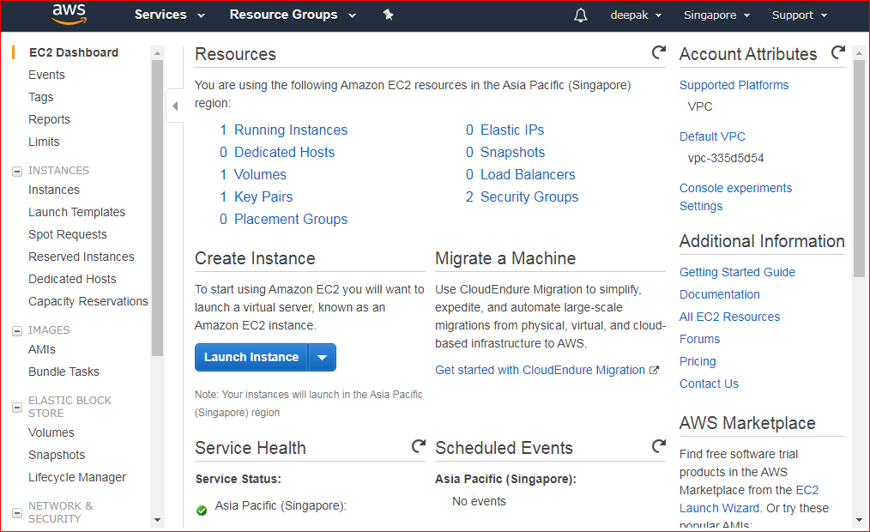

***Now choosing the Ubuntu 18.04 server as given below...***

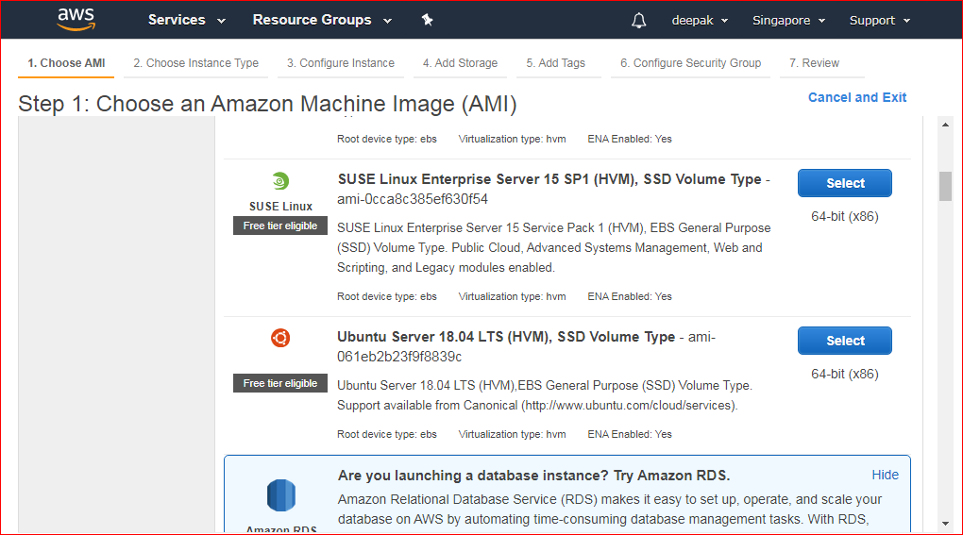

*Now We will choose t2.micro instance type, which has 1GB memory offered by AWS.*

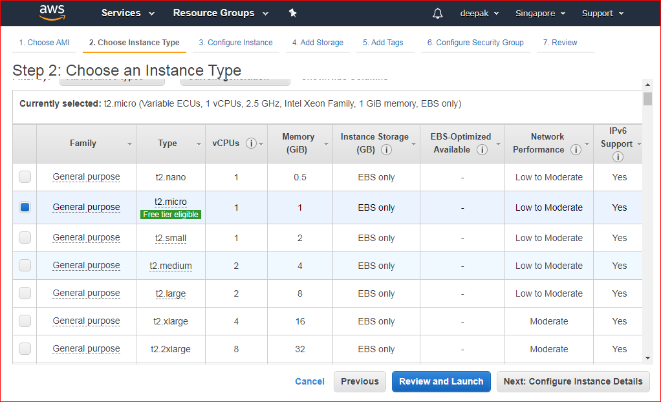

***Now click on Next: Configure instance details:***

***Now again click on Next: Add etorage***

***Instance automatically provisioned a General Purpose SSD root volume of 8GB.You can change your volume size, add new volumes, And can change thevolume type, etc.***

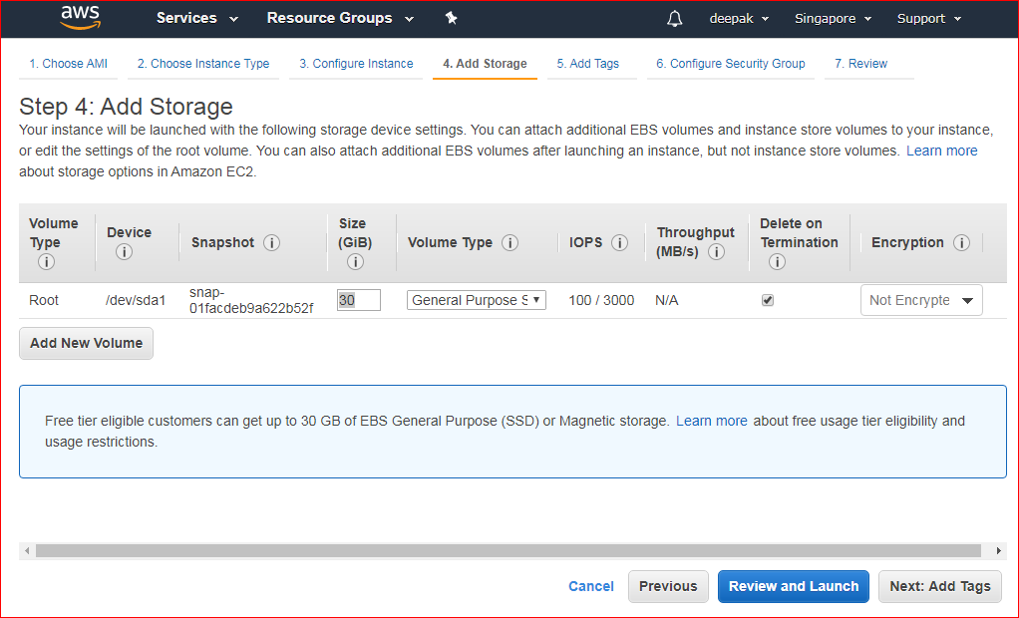

*Now click on Next: Add Tags*

*And after it click on Next: Configure Security Group*

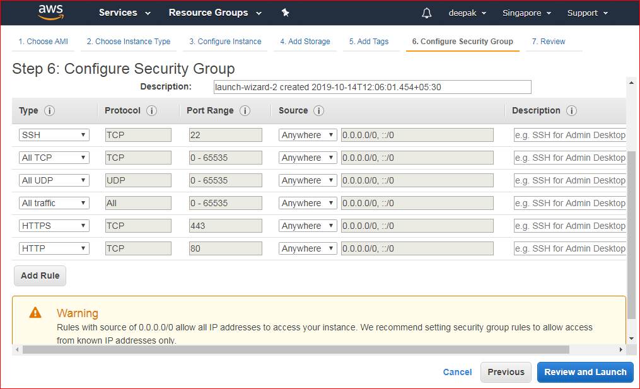

*Now click on Review And Launch*

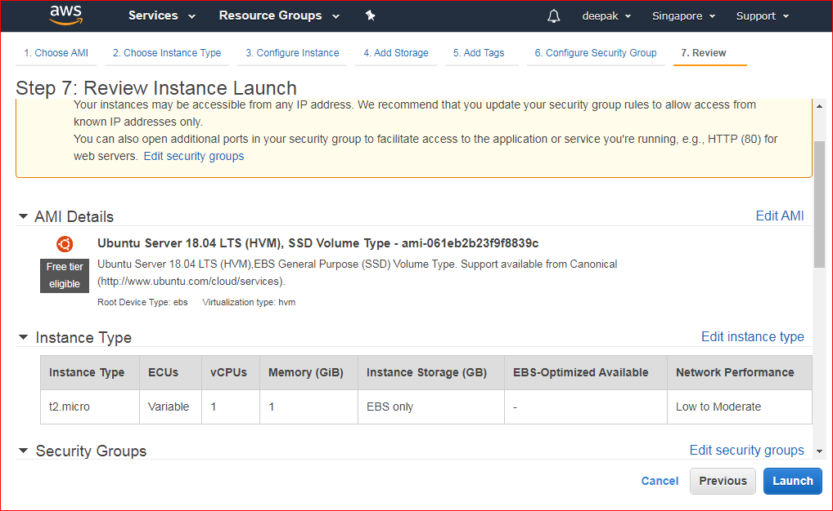

*Now click on launch*

***In the next step you will be asked to create a key pair to login to you an instance. A key pair is a set of public-private keys.***

*1.Create a new key pair*

*2.Give a name to your key*

*3.Download and save it in your secured folder*

*To generate a new key pair click on Create a new key pair*

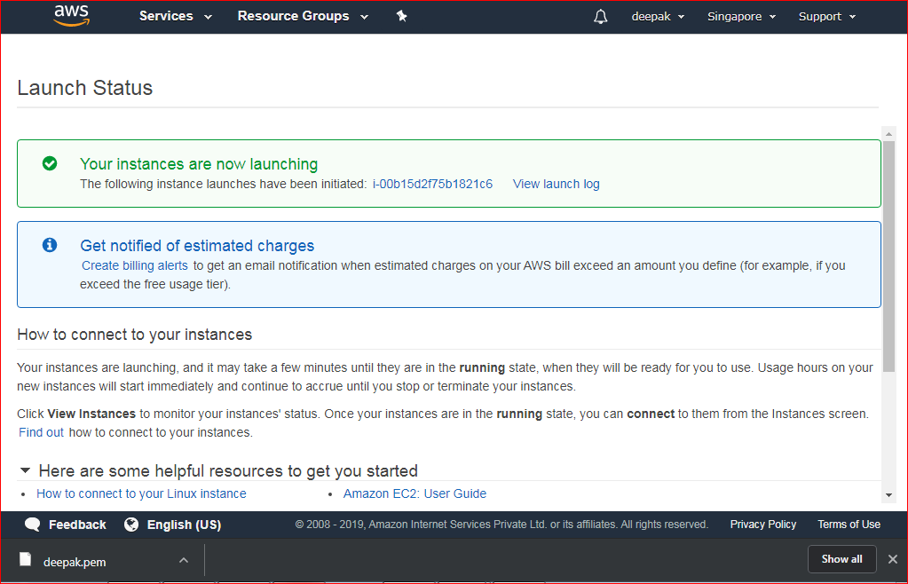

***Once your instance is up and running, you can see its status as 'Running' now.***

